9 Weeks' Test
- Which of the following quantities is not a vector?
  - Electric Field
  - Magnetic Field
  - Electric Potential
  - Force
  - velocity

- Consider four charges, A, B, C and D, that exist in a region of space. Charge A attracts charge B, but B repels C. C repels D and D is positively charged. What is the sign of the charge A?
  - Positive
  - Negative
  - Neutral
  - All of the charges are positive.
  - All of the charges are negative.

- A proton is traveling to the left through a magnetic field that is directed into the page. The force on the proton is -
  - toward the top of the paper
  - toward the bottom of the paper
  - toward the left side of the paper
  - toward the right side of the paper
  - into the paper.

- A wire carries an unknown amount of current, I. The magnetic field at a fixed distance from the wire is measured to be 0.3 T. A short time later, the magnetic field is measured to be 0.6 T. The current in the wire is now -
  - I/4
  - I/2
  - I
  - 2I
  - It cannot be determined from the information provided.

- A capacitor has a capacitance of 2 μF. If the area of the plates were doubled, and the separation between the plates was halved, what would the new capacitance be?
  - 0.5 μF
  - 1 μF
  - 2 μF
  - 4 μF
  - 8 μF

- Two parallel conducting plates are connected to a constant voltage source. The magnitude of the electric field between the plates is 2,000 N/C. If the voltage is doubled and the distance between the plates is reduced to 1/5 the original distance, the magnitude of the new electric field is
  - 800 N/C
  - 1,600 N/C
  - 2,400 N/C
  - 5,000 N/C
  - 20,000 N/C
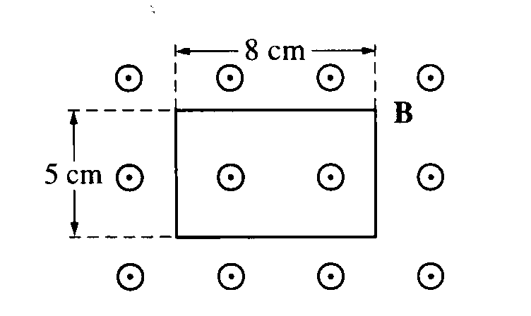
- A rectangular wire loop is at rest in a uniform magnetic field B of magnitude 2 T that is directed out of the page. The loop measures 5 cm by 8 cm, and the plane of the loop is perpendicular to the field, as shown above. The total magnetic flux through the loop is
  - zero
  - 2 x 10⁻³ Tm²
  - 8 x 10⁻³ Tm²
  - 2 x 10⁻¹ Tm²
  - 8 x 10⁻¹ Tm²

